

19P0012 AITZAZ TAHIR CH

DATA BASE LAB 12 SIR MUHAMMAD USMAN



**Exercises**

**1) Create a database named your rollno_section (i.e. 18P0014_6B).**

use 19P0012_4A

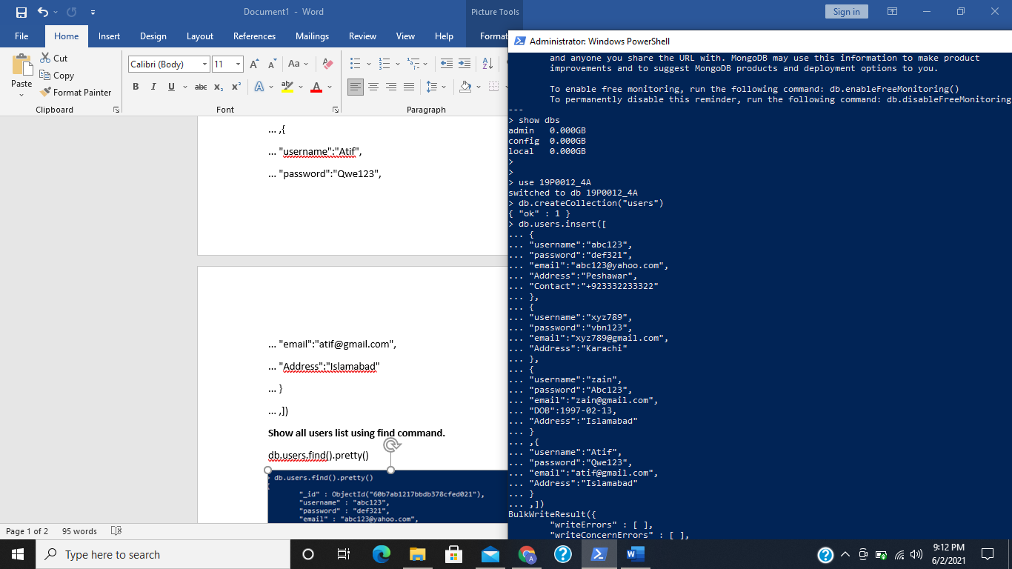

**2) Create collections named cities and moviepeople_1000.**

db.createCollection("cities")

db.createCollection("moviepeople_1000")

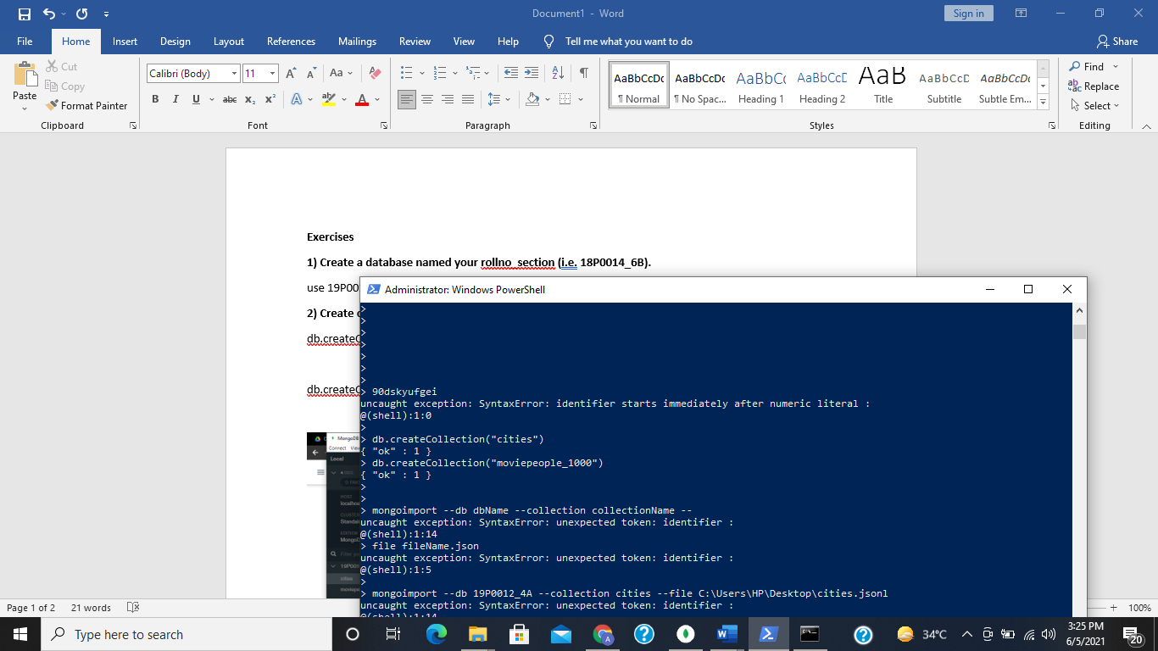

**3) Import the documents cities.jsonl and moviepeople-1000.jsonl into the cities and**

**moviepeople collection respectively by issuing the following command.**

**Importing cities.jsonl**

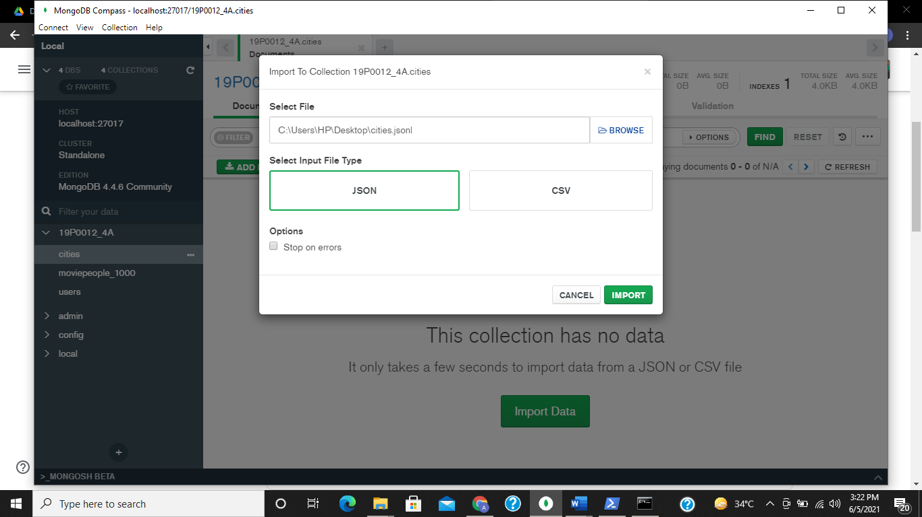

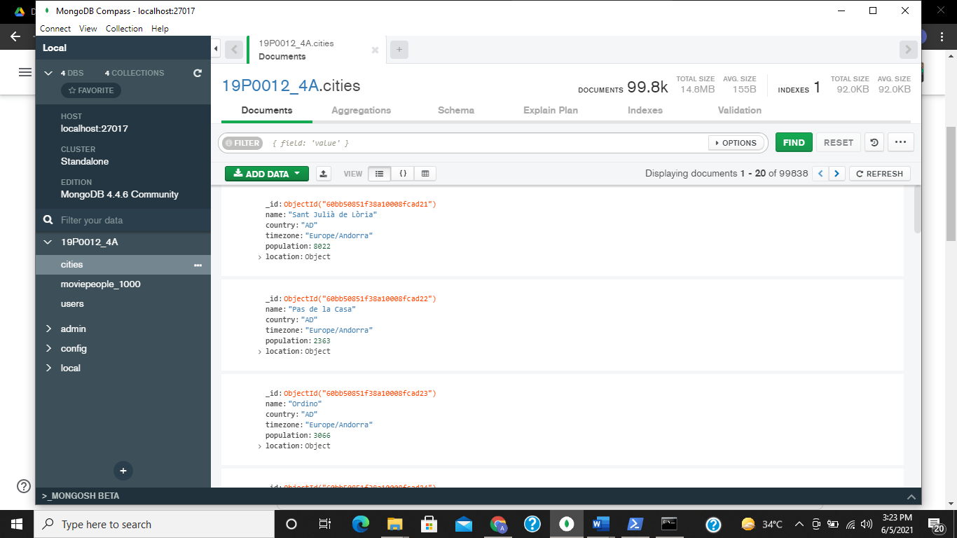

**Importing moviepeople-1000.jsonl**

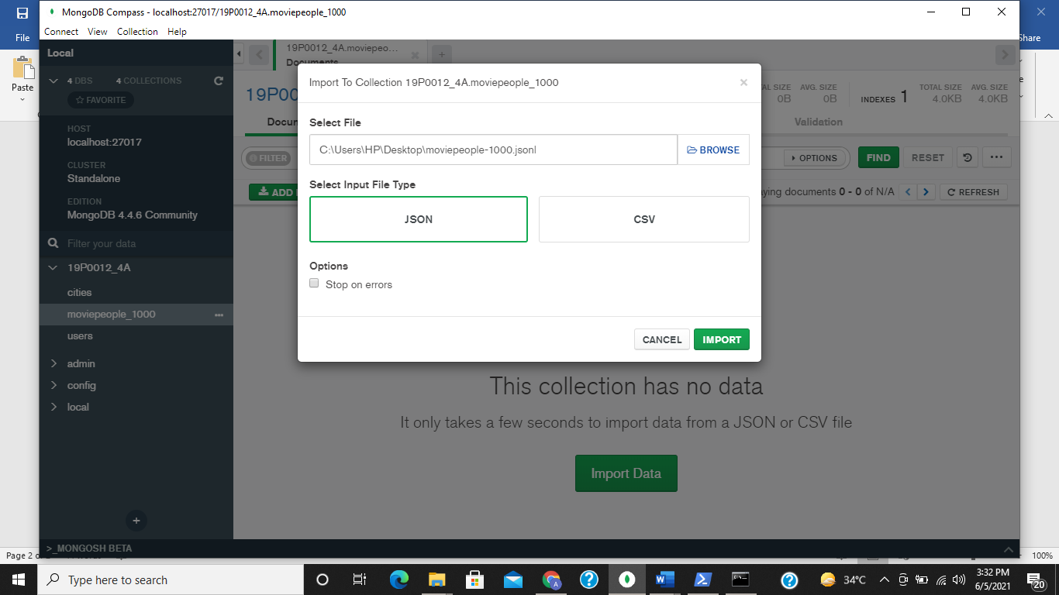

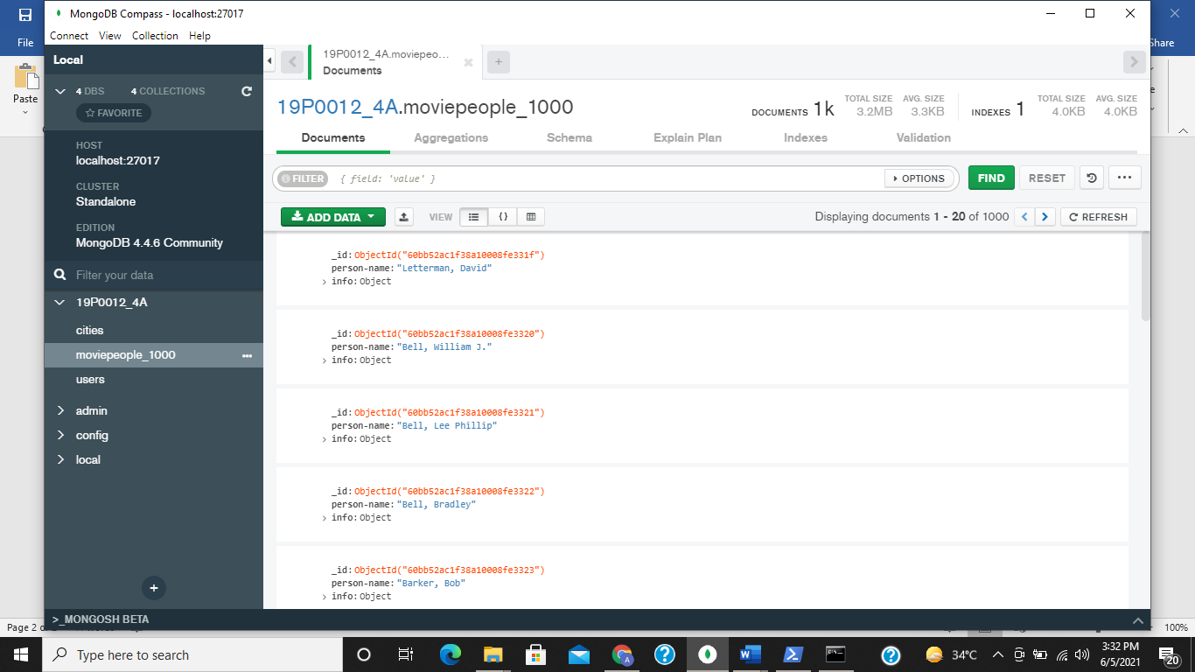

**4) In the mongo shell client, write queries for finding: (hint: use cities collection)**

**i. All those cities whose time zone is Africa/Harare.**

db.cities.find({timezone:"Africa/Harare"}).pretty()

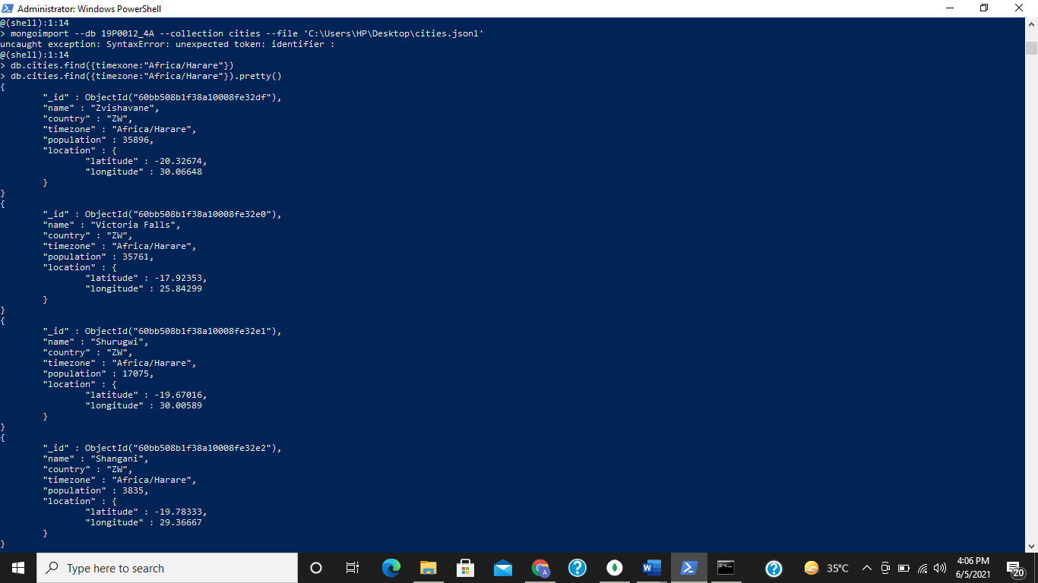 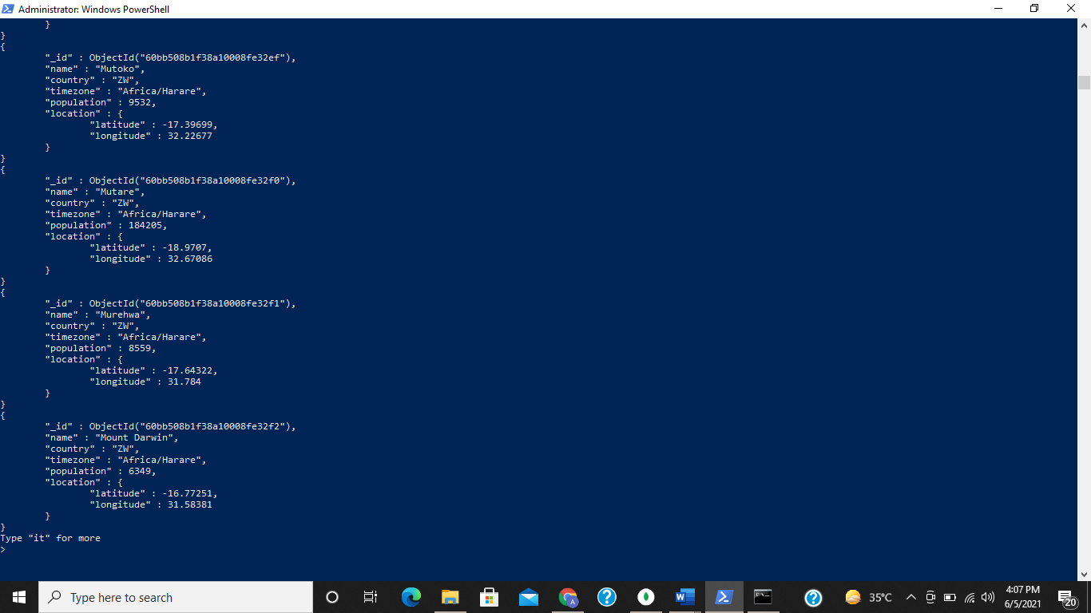

**ii. All those cities whose population is greater than 12985000.**

db.cities.find( { population:{ $gt: [12985000] } } ).pretty()

no population data is greater than given value so it outputs nothing

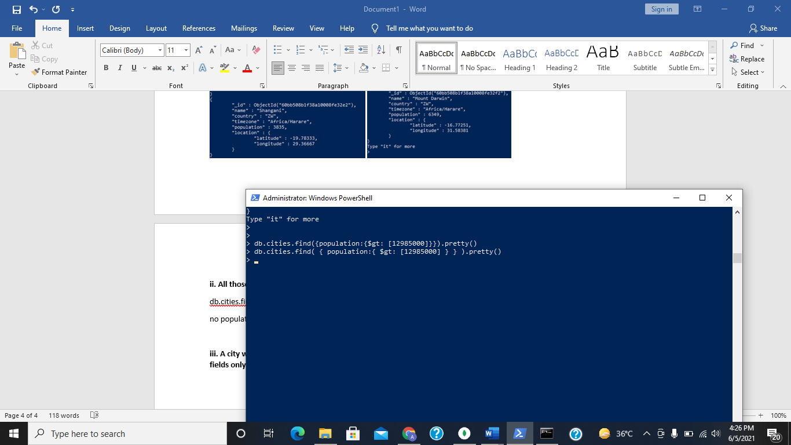

**iii. A city whose longitude equals to -58.37723. Your query should return location and population fields only. (hint: use projection)**

db.cities.find( {"location.longitude":-58.37723}, {_id:0, name:0, country:0, timezone:0} ).pretty()

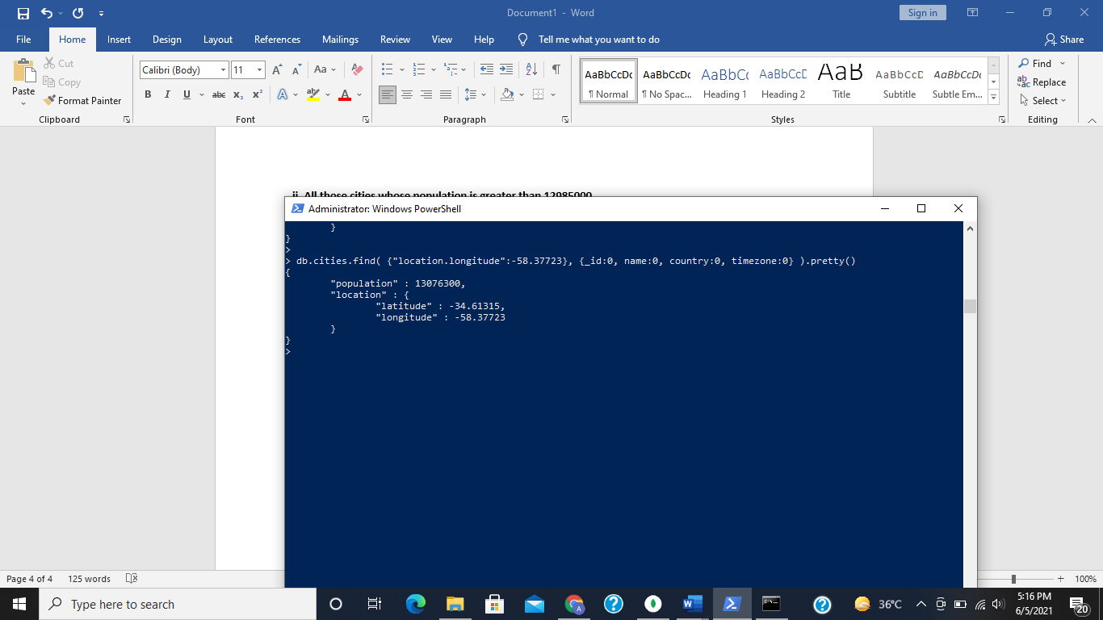

**5) Write a query to update the population from 35000 to 55000 whose country is PK and a location latitude of 73.2122. (hint: use cities collection)**

db.cities.updateMany({"population":35000,"country":"PK","location.latitude":73.2122},{$set

:{"population":55000}})

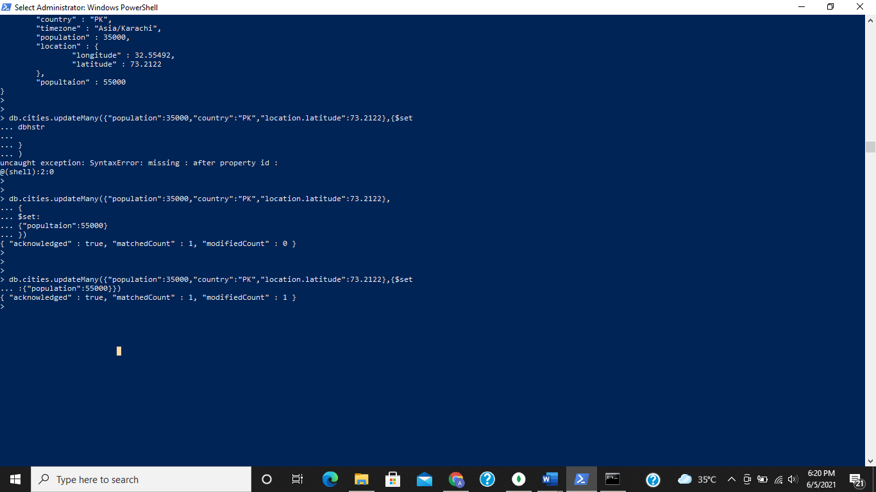

**6) Write a query to delete the document whose timezone is Asia/Karachi and a country is PK. (hint: use cities collection)**

db.cities.deleteMany({"timezone":"Asia/Karachi","country":"PK"})

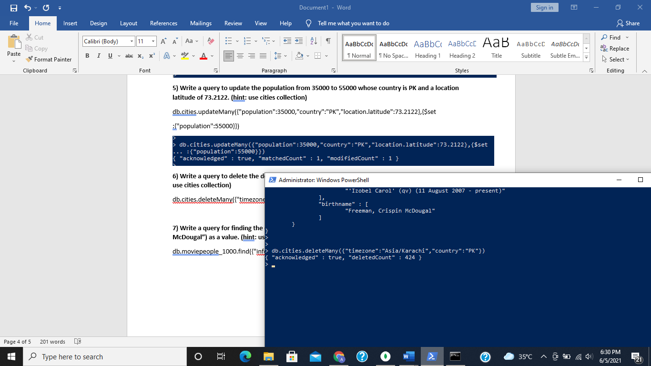

**7) Write a query for finding the document whose birthname name array contains (“Freeman, Crispin McDougal”) as a value. (hint: use moviepeople collection)**

db.moviepeople_1000.find({"info.birthname":"Freeman, Crispin McDougal"}).pretty()

